PM1: Choose a map to criticize in PM2 and provide its URL
(the map should be a full map, not a part of a map)
Source of the map (URL) (10 points):
http://www.esri.com/news/arcnews/fall12articles/european-cities-are-getting-warmer.html

Image of the map or screenshot (10 points):

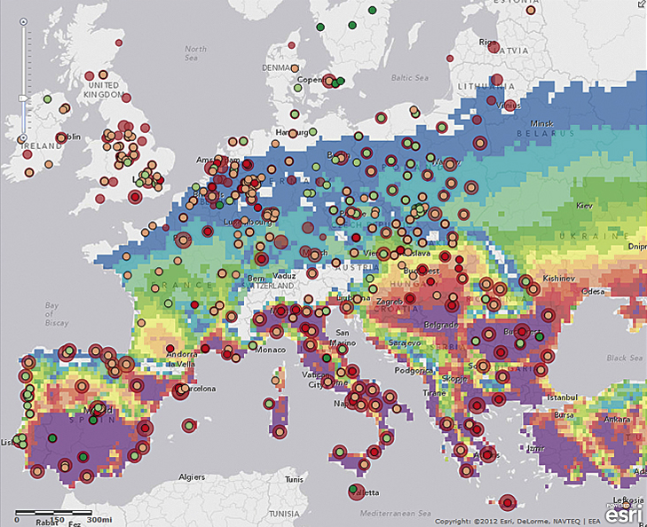
PM2: Your own critiques about the above map (NOT required for PM1. When you will submit your PM2 assignment, please include your PM1 assignment sheet on the top so that the map can be seen with your critiques.)

- Theme or subject in the map, author(s), and the source of data used in the map
The theme of the map is a temperature related. This is about rising temperatures in Europe, possible leading to heatwaves, and so forth. This article is created by Esri. The tools used is ArcGIS Online. The sources they used is datasets from readings such as databases and atlas’. The article is created in 2012.

- Data type (nominal, ordinal, interval, or ratio), generalization applied (8 types: refer the lecture note for the details), classification applied (number of classes, classification methods: refer the lecture note for the details), and projection applied (for example, cylindrical, conic, or azimuthal), if used in the map.

Data of this map uses . Some of the generalization is applied to this map such as . Some Classification are represented, such as . The map uses ___ projection.

- Design (map elements: title, legend, scale bar, north arrow, map content, labels), color schemes (binary, qualitative, sequential, or diverging), graphing, symbols, visual center, eye movement, visual hierarchy, and etc., if used in the map

This map uses some multivariate mapping practices and the use of the color plates. Using complementary colors, from blue to purple. The colors are rated from the coldest to the warmest in temperature. The map uses some dot density to represent population density.

- Spatial and/or temporal interpretation of the map (i.e., spatial patterns of the data distributed). You could describe how the pattern of the phenomena is distributed on the map. For example, you could mention where you find high/medium/low degree of the phenomena. If it is spatio-temporal, you could also mention how the pattern is based on time and location.

- Strength, limitation, and possible improvement of the map

